Tutorial 15

Module Name: Login, Authentication, Assertion & Exception Handling
Test Case ID: TC15
Tester Name: Vora Riya

Scenarios:
- Scenario ID: LOGIN01
Scenario
Valid login
Test Steps
1. Open SauceDemo.
2. Enter valid credentials.
3. Click Login.

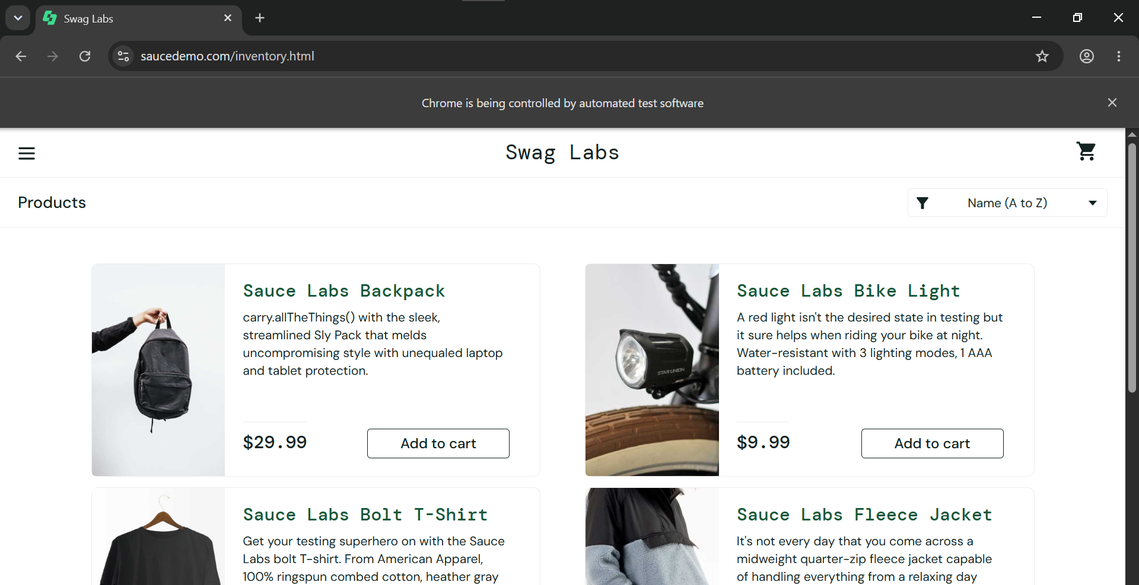

- Scenario ID: LOGIN02
Scenario
Invalid username
Test Steps
1. Open SauceDemo.
2. Enter an invalid username.
3. Enter a valid-format password.
4. Click Login.

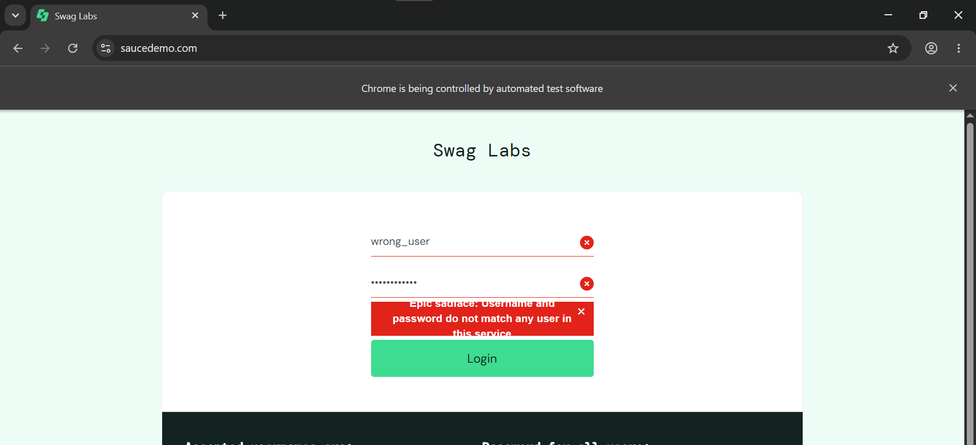

- Scenario ID: LOGIN03
Scenario
Invalid password
Test Steps
1. Open SauceDemo.
2. Enter a valid username.
3. Enter an incorrect password.
4. Click Login.
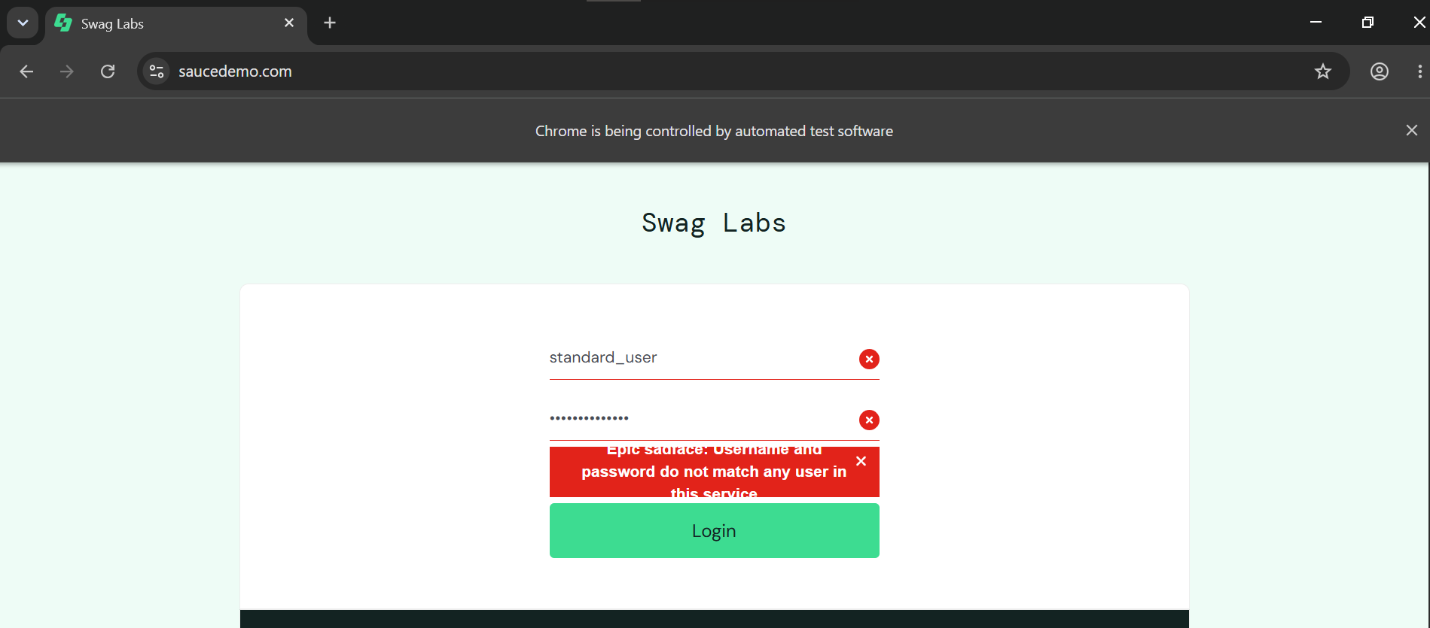

- Scenario ID: LOGIN04
Scenario
Blank values
Test Steps
1. Open SauceDemo.
2. Leave the values blank.
3. Click Login.
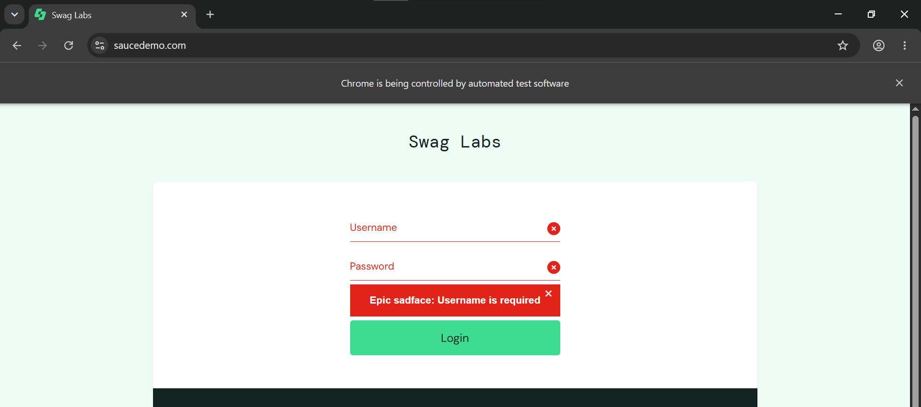

- Scenario ID: LOGIN05
Scenario
Verify logout
Test Steps
1. Log in with valid credentials.
2. Open the menu.
3. Click Logout.
4. Verify the resulting page.
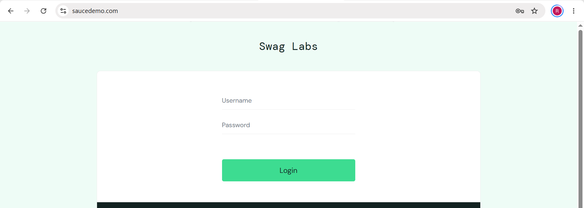

- Code:
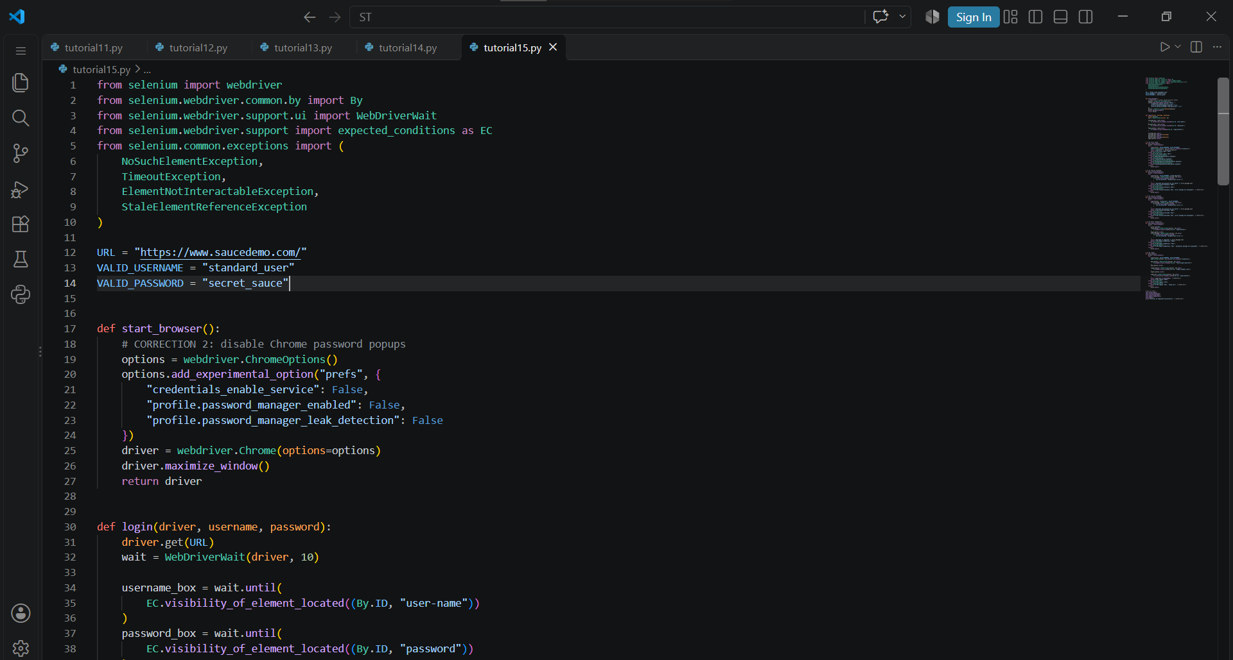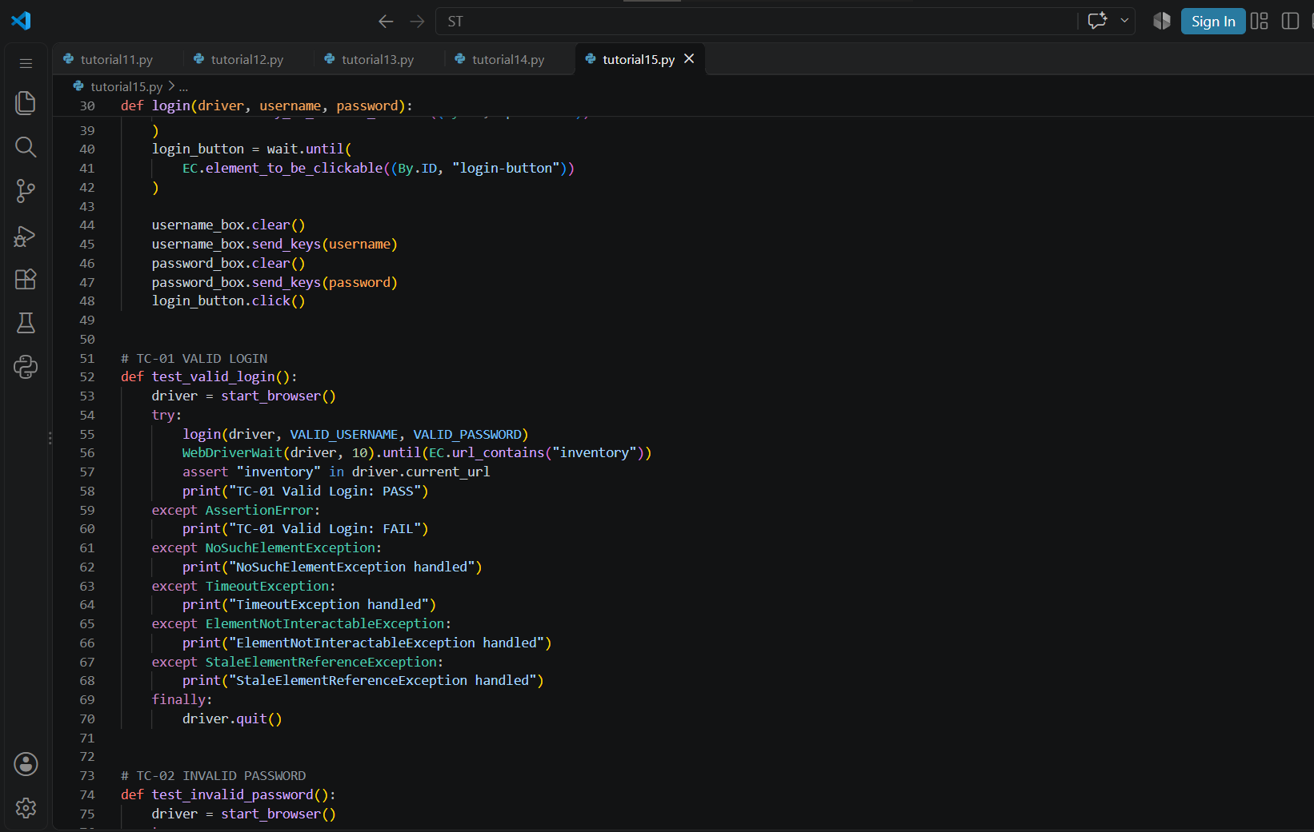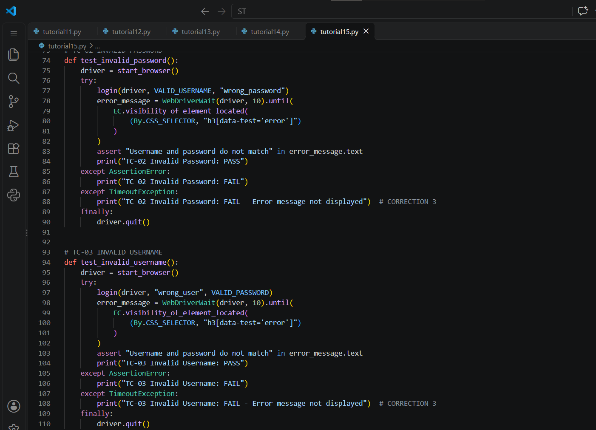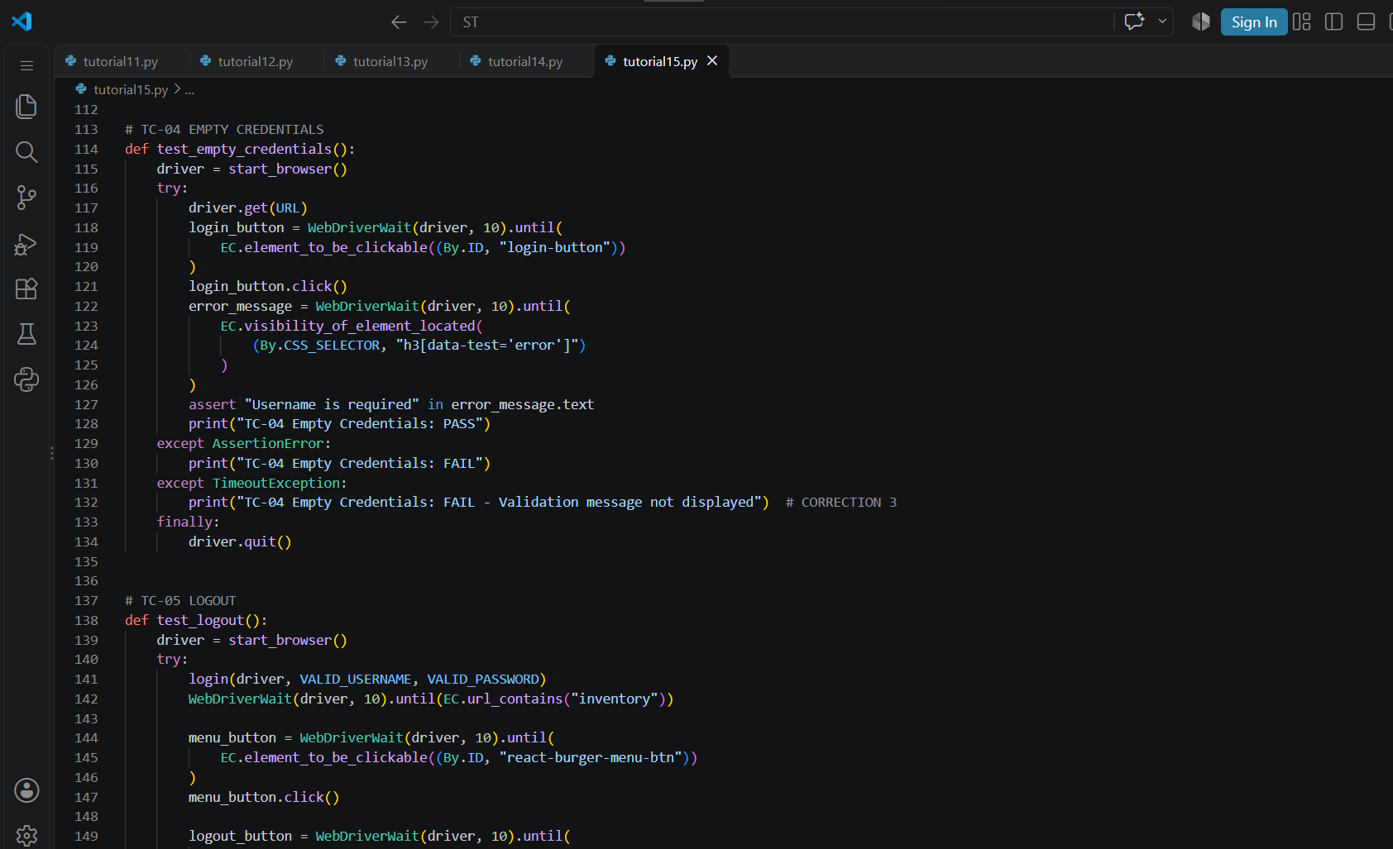

- Console Output:
